Calculator – Detailed Explanation

1. Introduction
A calculator is an electronic device used to perform mathematical calculations quickly and accurately. It is commonly used by students, teachers, engineers, accountants, and professionals. Calculators reduce manual effort and help avoid calculation errors.

2. Types of Calculators
- Basic Calculator – Used for simple arithmetic operations
- Scientific Calculator – Used for advanced mathematical and scientific calculations
- Graphing Calculator – Used to draw graphs and solve complex equations
- Financial Calculator – Used in accounting and business calculations

3. Main Parts of a Calculator
A calculator consists of the following main parts:

3.1 Display Screen
- Shows numbers, symbols, and calculation results
- Usually an LCD or LED screen
- Can display one or multiple lines depending on the calculator type
Example:
When you press 8 + 2 =, the screen displays 10

3.2 Number Keys (0–9)
- Used to enter numbers
- Includes digits from 0 to 9
- Some calculators include a decimal point (.)
Example:
To type 25.6 → Press 2, 5, ., 6

3.3 Arithmetic Operation Keys
- It has openings for the keys and display.
- Made of plastic to keep the calculator light and durable.

- parts tightly in place.

These keys perform basic mathematical operations:
Key | Function
+ | Addition
− | Subtraction
× | Multiplication
÷ | Division
% | Percentage
Example:
50 × 2 = 100

3.4 Equal (=) Key
- Displays the final result of a calculation
- Executes the entered operation
Example:
7 + 3 = → 10

3.5 Clear (C / AC) Key
- Clears input or resets the calculator
- C clears the current entry
- AC (All Clear) resets all calculations

4. Scientific Calculator Special Functions
(Insert Image 3: Scientific calculator buttons explained)

4.1 Trigonometric Functions
- sin, cos, tan
- Used in geometry and trigonometry
Example:
sin 30° = 0.5

4.2 Power and Root Functions
- x² – Square of a number
- √ – Square root
- xʸ – Power function
Example:
√16 = 4

4.3 Logarithmic Functions
- log – Base 10 logarithm
- ln – Natural logarithm
Used in advanced mathematics and science.

4.4 Memory Buttons
Button | Function
MC | Memory Clear
MR | Memory Recall
M+ | Add to memory
M− | Subtract from memory
These buttons help store numbers temporarily.

5. Power Source
- Calculators work using:
  - Battery
  - Solar panel
  - Both battery and solar
Solar calculators save energy and work in light.
6. Advantages of a Calculator
- Fast and accurate calculations
- Saves time
- Reduces human errors
- Useful for large and complex calculations

7. Disadvantages of a Calculator
- Overuse may reduce mental math skills
- Dependent on power source
- Not allowed in some examinations

Purpose of the product

The main purpose of a calculator is to perform mathematical calculations quickly, accurately, and efficiently. It is designed to reduce human effort and minimize errors in calculations.

Detailed Purposes of a Calculator:
- Perform Basic Arithmetic Operations
A calculator is used to carry out addition, subtraction, multiplication, and division easily.
- Solve Complex Mathematical Problems
Scientific calculators help in solving trigonometric, logarithmic, algebraic, and exponential problems.
- Save Time and Increase Speed
Calculations that take a long time manually can be completed in seconds using a calculator.
- Improve Accuracy
It reduces mistakes that commonly occur in mental or written calculations.
- Support Education and Learning
Students use calculators to verify answers, learn complex concepts, and solve advanced problems.
- Assist Professional Work
Used by engineers, accountants, scientists, bankers, and researchers for accurate calculations.
- Handle Large Numbers
Calculators can easily manage very large or very small numbers that are difficult to calculate manually.
- Store and Recall Data
Memory functions allow users to store numbers for repeated use.
- Enhance Productivity
By simplifying calculations, calculators help users focus on problem-solving rather than manual computation.
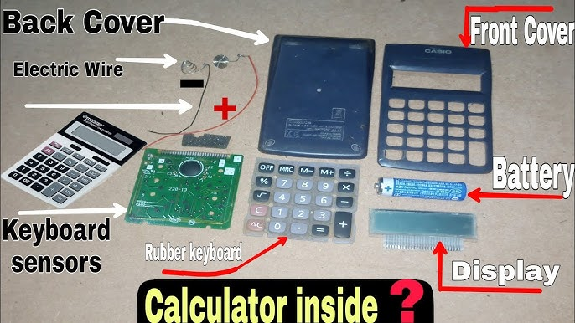
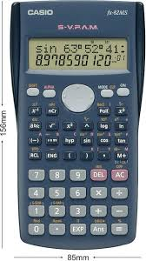

Parts of a Calculator (Explanation)

1. Front Cover
- The front cover protects the calculator.
- It has openings for the keys and display.
- Made of plastic to keep the calculator light and durable.

2. Back Cover
- The back cover holds all internal parts tightly in place.
- It protects the circuit and battery from dust and damage.
- Usually fixed with small screws.

3. Battery
- The battery is the power source of the calculator.
- It supplies DC electric current to all components.
- Commonly a dry cell or button cell.
4. Electric Wire
- Electric wires connect the battery to the circuit board.
- They carry electric current to the IC, display, and keypad.
- Made of copper with insulation.

5. Circuit Board (PCB)
- The printed circuit board holds all electronic components.
- It contains the IC (Integrated Circuit) which performs calculations.
- Copper tracks act like internal wiring.

6. Keyboard Sensors
- These are conductive contacts on the circuit board.
- When a key is pressed, the sensor sends a signal to the IC.
- Helps the calculator recognize which key is pressed.

7. Rubber Keyboard
- The rubber keyboard sits above the sensors.
- Each rubber button has a conductive pad at the bottom.
- Pressing a key completes the circuit.

8. Display
- The display (LCD) shows numbers and symbols.
- It receives signals from the IC.
- Uses very little power.

9. Solar Panel (if present)
- Converts light energy into electrical energy.
- Helps reduce battery usage.

